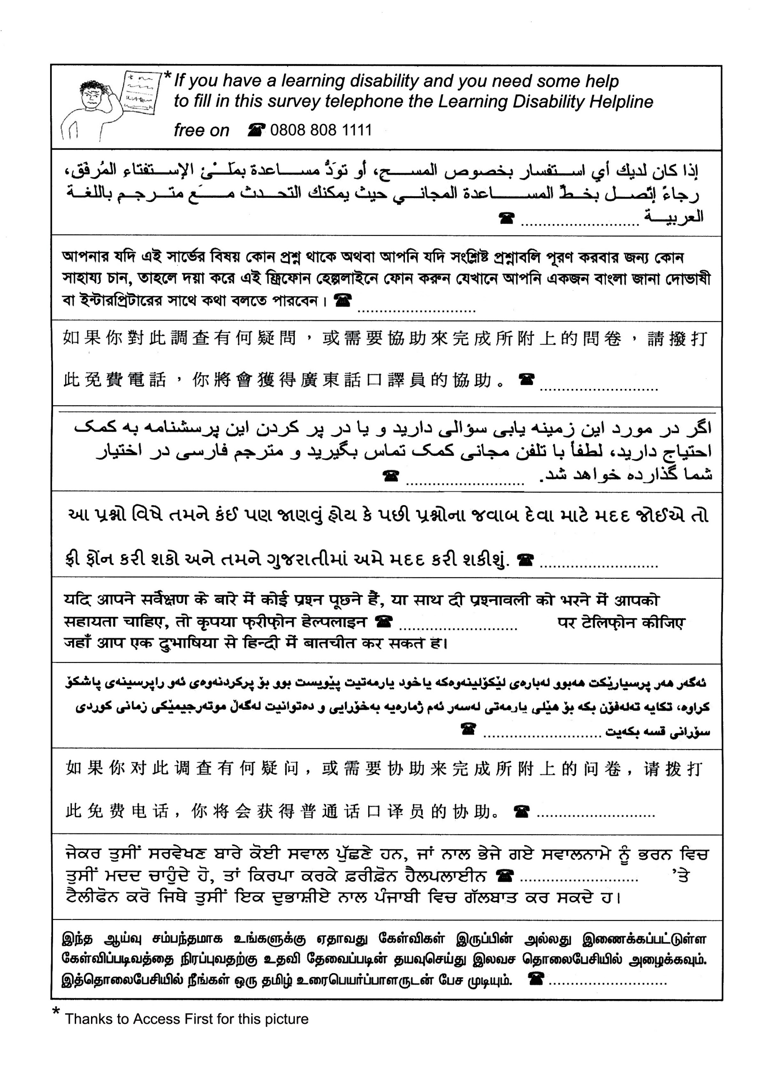

[INSERT HELPLINE]
[INSERT HELPLINE]
[INSERT HELPLINE]
[INSERT HELPLINE]
[INSERT HELPLINE]
[INSERT HELPLINE]
[INSERT HELPLINE]
[INSERT HELPLINE]
[INSERT HELPLINE]
[INSERT HELPLINE]
If you have any questions about this survey, or you would like help completing it, please call the FREEPHONE number on [INSERT HELPLINE] in order to speak to an interpreter.

LANGUAGE HELP?

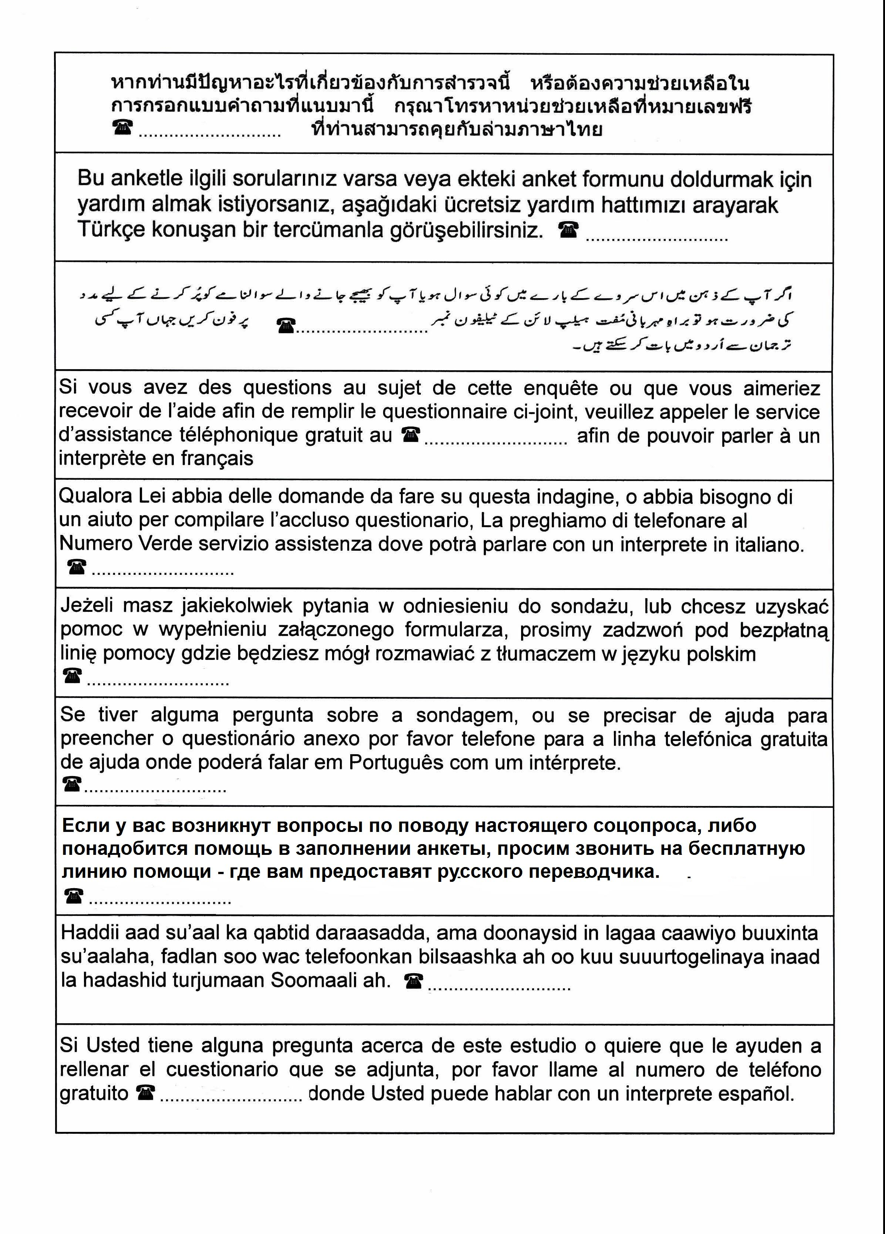

[INSERT HELPLINE]
[INSERT HELPLINE]
[INSERT HELPLINE]
[INSERT HELPLINE]
[INSERT HELPLINE]
[INSERT HELPLINE]
[INSERT HELPLINE]
[INSERT HELPLINE]
[INSERT HELPLINE]
[INSERT HELPLINE]
If you have a learning difficulty and you need some help to fill in this survey, please telephone Mencap Direct Advice and Information Service free on 0808 808 1111

LEARNING DIFFICULTY?

